Project Design Phase-II
Technology Stack (Architecture & Stack)

Date | 31 January 3035
Team ID | 699d5fb73074df695bbbb046
Project Name | HouseRent Management
Maximum Marks | 4 Marks

Technical Architecture:
The Deliverable shall include the architectural diagram as below and the information as per the table1 & table 2
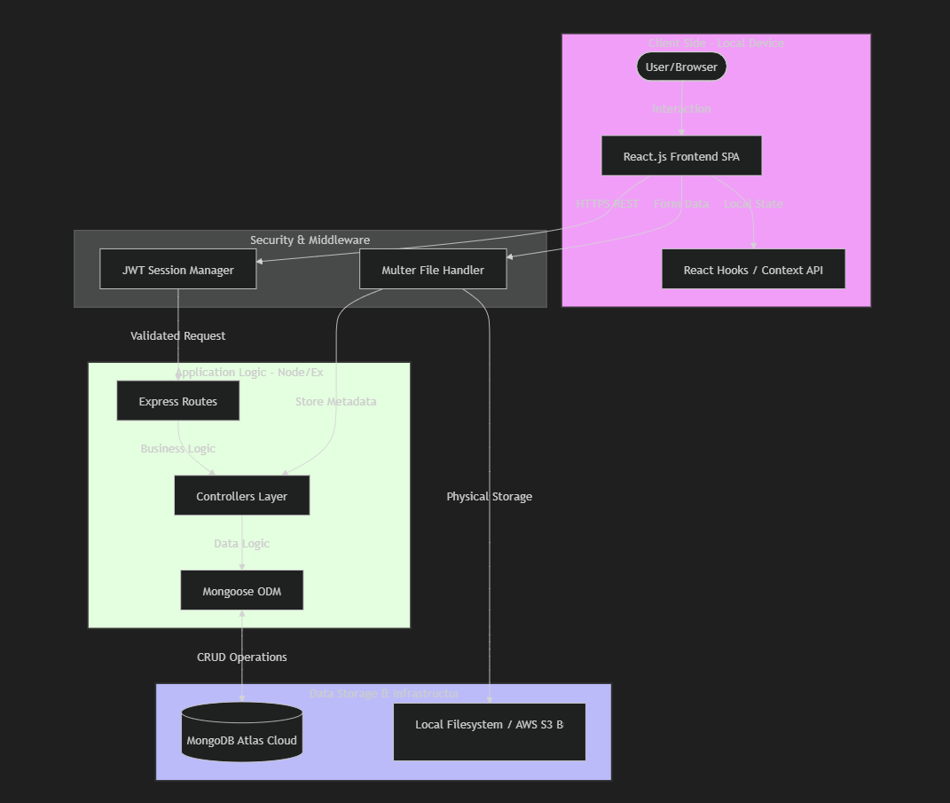

Technology Stack (Architecture & Stack)
Table-1: Components & Technologies
S.No. | Component | Description | Technology
1. | User Interface | Responsive web frontend for property interaction. | React.js / Bootstrap
2. | Application Logic | RESTful API server for business logic processing. | Node.js / Express.js
3. | Database | NoSQL storage for flexible property schemas. | MongoDB / Mongoose
4. | File Storage | Local/Cloud storage for property images. | Multer / FS
5. | Security | Industry-standard authentication mechanisms. | JWT / Bcrypt.js

Table-2: Application Characteristics
S.No. | Characteristics | Description | Technology
1. | Open-Source Frameworks | List of primary open-source libraries used. | MERN Stack
2. | Security Implementations | Data protection and access controls. | JWT, Bcrypt, CORS
3. | Scalable Architecture | 3-tier architecture with modular controllers. | Express/Node
4. | Availability | Cloud-ready database and deployment targets. | MongoDB Atlas
5. | Performance | Efficient query processing and caching. | Indexing / Morgan

